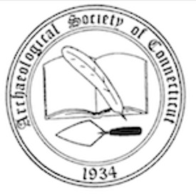
Archaeological Society of Connecticut

BRIAN D. JONES GRANT APPLICATION

Name:

Address:

E-mail:_

Current ASC member: Yes  No 

Institutional Affiliation (if any):

Location where archaeological research will be conducted:

Dates when research will be conducted (including projected date of completion):

On separate sheet(s) please answer the following questions:

- Please describe, in 200-500 words, the archaeological research you propose to carry out. Include a description of your research question(s), goals, and proposed methods, as well as a brief discussion of the broader implications of the research to Connecticut archaeology and our understanding of the past.

- Who will be supplying labor for this research? (Please attach a resume or CV for each researcher. Also attach a letter of recommendation from a member of the professional archaeological community.)

- For what do you specifically anticipate using the Jones funding? (Please attach a proposed budget.)

As a condition of this award, I agree that the results of my research will be shared with the Archaeological Society of Connecticut in the form of a final contribution to the Bulletin and/or contributions to the newsletter as research proceeds.

Signature

Date

Please e-mail the completed application to:

ctarchaeology@gmail.com

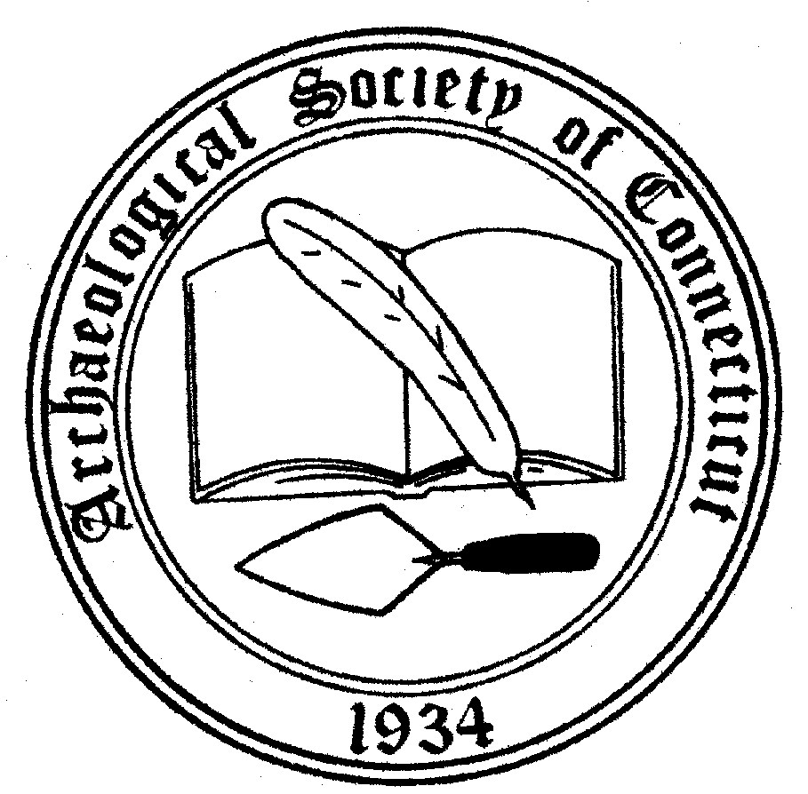 | THE  BRIAN D. JONES GRANT

In February 2020 the Directors of the Archaeological Society of Connecticut renamed the Lyent Russell Award the Brian D. Jones Grant, in honor of our late friend and colleague, who served as Connecticut State Archaeologist and as a Director of the Society until his untimely passing in 2019. This will also reduce the confusion between the Lyent Russell Award which is a grant to researchers, and the Russell Memorial Award, which was established by Lyent Russell, in memory of his parents Mr. and Mrs. Berne A. Russell and his wife Althea Marsh Russell. The award was to be granted in recognition of “outstanding contributions to the Archaeological Society of Connecticut”.

A committee of the Society will be accepting applications for the Brian D. Jones Grant from Society members for a grant to be awarded at the fall meeting of the Society. It is expected that the funds up to a maximum of $1,500 will be utilized within a year of the award. Preference will be given to those practicing archaeology as an avocation and/or without institutional affiliation, although no one who applies will be rejected for not meeting these criteria. Selection will also be based upon immediacy of need; i.e. the degree that a site is threatened and the shortness of the time frame within which research must be finished. It is also expected that once the research is finished the results will be shared with the Society in the form of a Bulletin or newsletter article.

